数组-**例题7-5 选择法排序之过程**

## 问题陈述

用选择排序法，将n个数从小到大排序，并且输出中间过程。

选择排序的算法步骤如下：

第0步：在未排序的*n*个数（*a*[0]〜 *a*[*n*−1]）中找到最小数，将它与 *a*[0]交换；

第1步：在剩下未排序的*n*−1个数（*a*[1] 〜 *a*[*n*−1]）中找到最小数，将它与 *a*[1] 交换；

……

第*k*步：在剩下未排序的*n*−*k*个数（*a*[*k*]〜*a*[*n*−1]）中找到最小数，将它与 *a*[*k*] 交换；

……

第*n*−2步：在剩下未排序的2个数（*a*[*n*−2] 〜*a*[*n*−1]）中找到最小数，将它与 *a*[*n*−2]交换

## 输入/输出描述

### 输入格式:

### 输入第一行给出一个不超过10的正整数*n*。第二行给出*n*个整数，其间以空格分隔

### 输出格式:

在每一行中输出排序过程中对应步骤的中间结果，即每一步后*a*[0]〜 *a*[*n*−1]的值，相邻数字间有一个空格，行末不得有多余空格。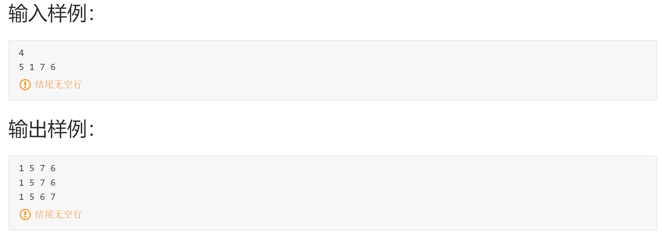

%3CmxGraphModel%3E%3Croot%3E%3CmxCell%20id%3D%220%22%2F%3E%3CmxCell%20id%3D%221%22%20parent%3D%220%22%2F%3E%3CmxCell%20id%3D%222%22%20style%3D%22edgeStyle%3Dnone%3Brounded%3D0%3BorthogonalLoop%3D1%3BjettySize%3Dauto%3Bhtml%3D1%3B%22%20edge%3D%221%22%20source%3D%223%22%20parent%3D%221%22%3E%3CmxGeometry%20relative%3D%221%22%20as%3D%22geometry%22%3E%3CmxPoint%20x%3D%22510%22%20y%3D%22220%22%20as%3D%22targetPoint%22%2F%3E%3C%2FmxGeometry%3E%3C%2FmxCell%3E%3CmxCell%20id%3D%223%22%20value%3D%22%22%20style%3D%22rounded%3D0%3BwhiteSpace%3Dwrap%3Bhtml%3D1%3B%22%20vertex%3D%221%22%20parent%3D%221%22%3E%3CmxGeometry%20x%3D%22360%22%20y%3D%22160%22%20width%3D%2280%22%20height%3D%22120%22%20as%3D%22geometry%22%2F%3E%3C%2FmxCell%3E%3CmxCell%20id%3D%224%22%20style%3D%22rounded%3D0%3BorthogonalLoop%3D1%3BjettySize%3Dauto%3Bhtml%3D1%3B%22%20edge%3D%221%22%20parent%3D%221%22%3E%3CmxGeometry%20relative%3D%221%22%20as%3D%22geometry%22%3E%3CmxPoint%20x%3D%22300%22%20y%3D%22189.76%22%20as%3D%22sourcePoint%22%2F%3E%3CmxPoint%20x%3D%22360%22%20y%3D%22190%22%20as%3D%22targetPoint%22%2F%3E%3C%2FmxGeometry%3E%3C%2FmxCell%3E%3CmxCell%20id%3D%225%22%20style%3D%22rounded%3D0%3BorthogonalLoop%3D1%3BjettySize%3Dauto%3Bhtml%3D1%3BentryX%3D0%3BentryY%3D0.75%3BentryDx%3D0%3BentryDy%3D0%3B%22%20edge%3D%221%22%20target%3D%223%22%20parent%3D%221%22%3E%3CmxGeometry%20relative%3D%221%22%20as%3D%22geometry%22%3E%3CmxPoint%20x%3D%22300%22%20y%3D%22250%22%20as%3D%22sourcePoint%22%2F%3E%3C%2FmxGeometry%3E%3C%2FmxCell%3E%3CmxCell%20id%3D%226%22%20value%3D%22%E7%82%B91%22%20style%3D%22text%3Bhtml%3D1%3BstrokeColor%3Dnone%3BfillColor%3Dnone%3Balign%3Dcenter%3BverticalAlign%3Dmiddle%3BwhiteSpace%3Dwrap%3Brounded%3D0%3B%22%20vertex%3D%221%22%20parent%3D%221%22%3E%3CmxGeometry%20x%3D%22260%22%20y%3D%22180%22%20width%3D%2240%22%20height%3D%2220%22%20as%3D%22geometry%22%2F%3E%3C%2FmxCell%3E%3CmxCell%20id%3D%227%22%20value%3D%22%E7%82%B92%22%20style%3D%22text%3Bhtml%3D1%3BstrokeColor%3Dnone%3BfillColor%3Dnone%3Balign%3Dcenter%3BverticalAlign%3Dmiddle%3BwhiteSpace%3Dwrap%3Brounded%3D0%3B%22%20vertex%3D%221%22%20parent%3D%221%22%3E%3CmxGeometry%20x%3D%22260%22%20y%3D%22240%22%20width%3D%2240%22%20height%3D%2220%22%20as%3D%22geometry%22%2F%3E%3C%2FmxCell%3E%3CmxCell%20id%3D%228%22%20value%3D%22%E4%B8%A4%E7%82%B9%E9%97%B4%E8%B7%9D%E7%A6%BB%22%20style%3D%22text%3Bhtml%3D1%3BstrokeColor%3Dnone%3BfillColor%3Dnone%3Balign%3Dcenter%3BverticalAlign%3Dmiddle%3BwhiteSpace%3Dwrap%3Brounded%3D0%3B%22%20vertex%3D%221%22%20parent%3D%221%22%3E%3CmxGeometry%20x%3D%22520%22%20y%3D%22210%22%20width%3D%2240%22%20height%3D%2220%22%20as%3D%22geometry%22%2F%3E%3C%2FmxCell%3E%3C%2Froot%3E%3C%2FmxGraphModel%3E

## 手动演算示例

根据输入样例**4**  5 1 7 6得出4个数的排序过程。

第一次排序为 1 5 7 6，第二次排序为 1 5 7 6，第三次排序为 1 5 6 7.

由此可得以上输出样例

## 算法设计

整体思路：先定义一个包含9个元素的数组**str并清零，**将n个数存入数组str中，接下来用两个变量控制内外循环，外变量控制第一个然后依次后移4，内变量遍历与外变量控制的数据进行比较，若满足条件即交换位置。

分解提纲：

1. 定义存放输入数据的str数组。
2. 输入需要比较大小的数据存入str中。
3. 遍历str数组，依次与之比较。
4. 之后进行比较，满足条件进行交换并打印中间过程。

根据分解提纲编写C语言程序如下：

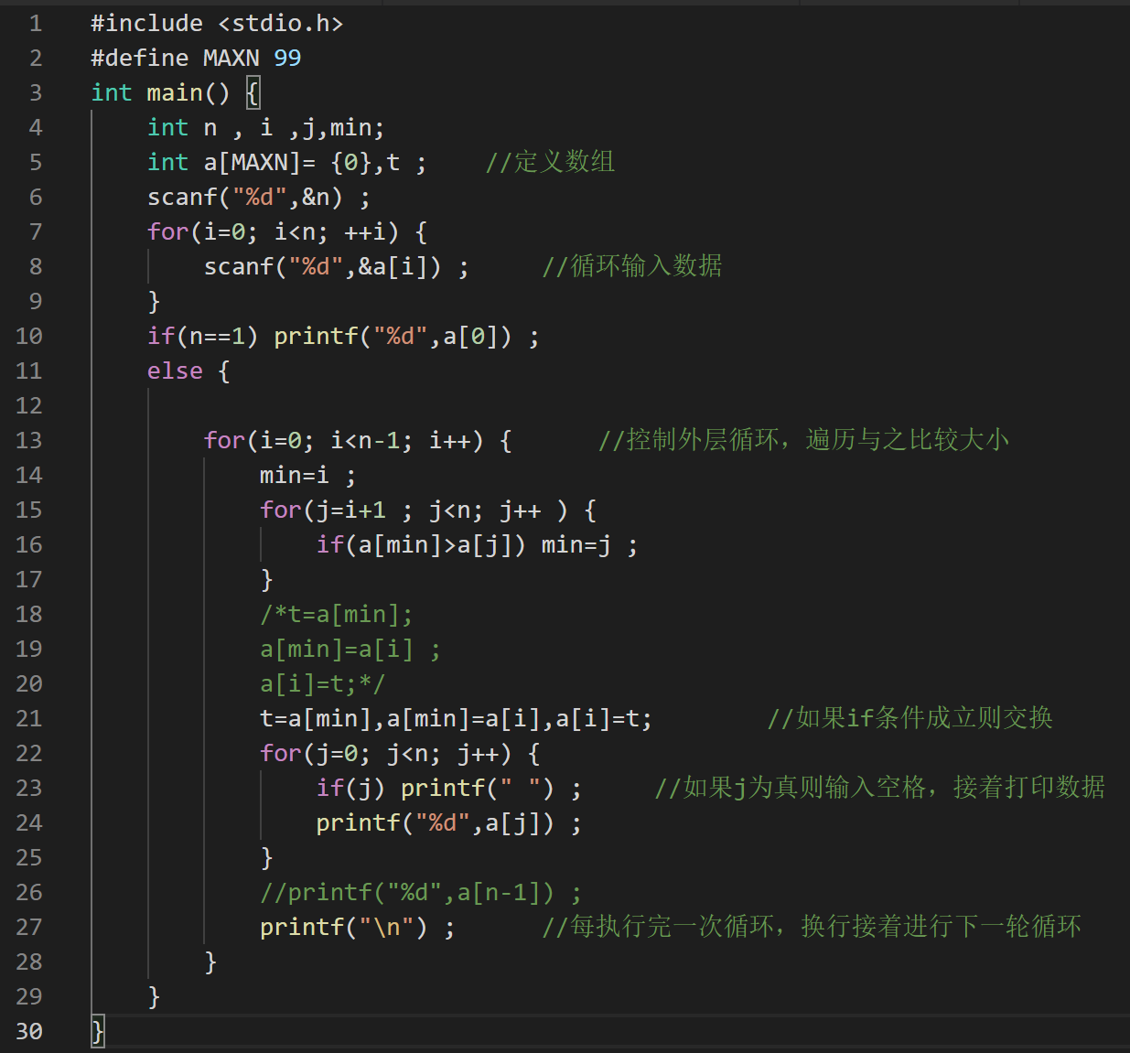

## 测试

已测试，通过PAT所有测试用例

思考：假设去掉12行的判定会怎样？

整理者：余青焱

更新日期：2021-11-28

参考文献：

1. Delores M. Etter 著, 宫晓利, 周阳, 张金 译, 工程问题C语言求解（原书第4版）, 北京: 机械工业出版社, 2016.